|  |
| --- |
|  |

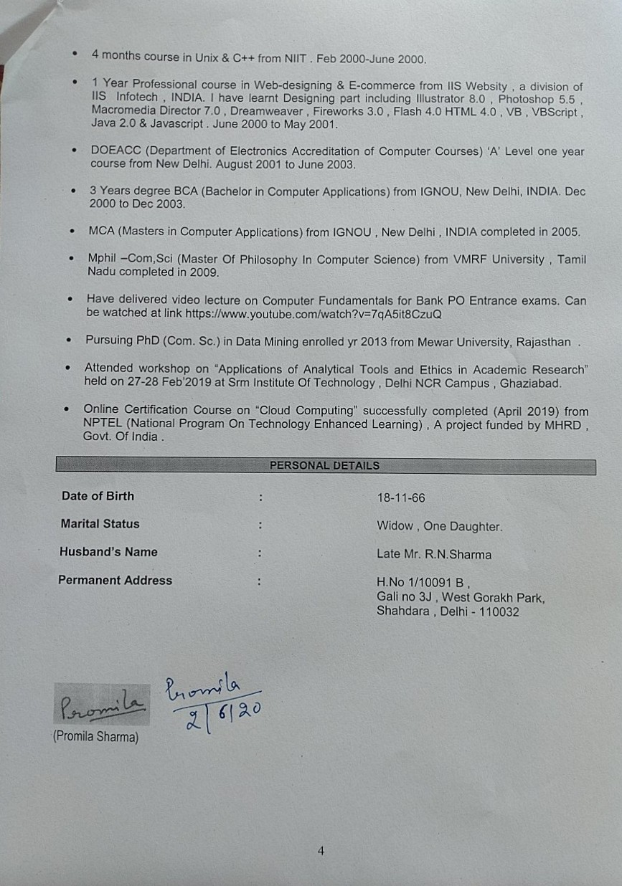

NATIONAL opyy

"*”’+



APPENDIX: SA MPLE TITLE PAGE

PROJEC TITLE

By Student’s full name

*Under Guidance*

Counsellor’s Full Name

Submitted to the School of Computer and Information Sciences In partial fulfillment of the requirements

For the degree of

Master Of Computer Applications

NAME---------------------------------------IMRAN

COURSE------------------------------------BCA

ENROLMENT NO--------------------------181030090

TOPIC------------------------------------------LIBRARY MANAGEMENT SYSTEM

EMAIL ID-----------------------------------------imran9205246469@gmail.com



GNOL . SLtIDA.h C.¥RHI. NE\Y DELHI — 110 068

II.

PROFOI IU

OF BG.t PAO.IECT PROPOSE

t BCSP-

(Pr«jvct’s Title and Guide’s Details I

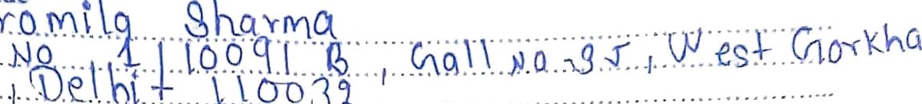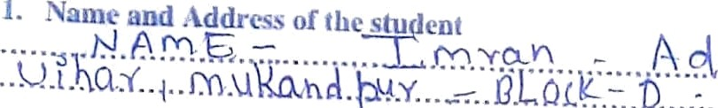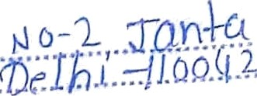

’. Tip fl Of the P rojyt

4.



Qunfificution of the dinide

*Ciimputer* Srirnce/IT *o*j’*

1. Industrial / Teaching expert me of the Guide tin Yearsj .
2. Software Used for thls Project: ... k .. . k.$.........



5ignamrc of the Students



5ignaiurc o1’ ibc Guide Qm



haportaat: t. .tttacb tbis Proforma doag nitb Guidc’• Biadato aJid Project Synopsis ia the Pzujuct Report.

For Office Use fhzly

 

Ap['OYed Not approv’cd

Sr Rmtiom for r‹ orionlalie« th Project:

Signatuix•. Designauon, Siainp ot ilic Date

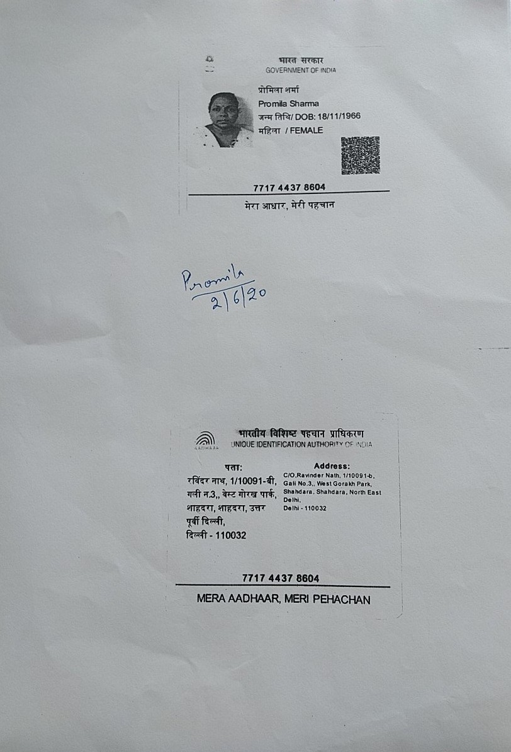



Introduction 5

Objective of the Project 6

4. METHODOLY 8

Modules to cover the general library functions of: 11

ER DIAGRAM 12

DFD Model 13

9. LIMITATION 14

Logic Model:- 15

PROCESS LOGIC :- 15

Scope of the LMS:-…………………………………………………………………………………………………………………………………17

Conclusion:-…………………………………………………………………………………………………………………………………………..18

# Introduction

Library Management System is a software used to manages the catalog of a library. This helps to keep the records of whole transactions of the books available in the library. AmpleTrails provides Library Management System which is very easy to use and fulfills all the requirement of a librarian.

Libraries play a crucial role in the education sector. It is regarded as the central system of any educational institution, whether it is small or large, colleges or universities. A transparent web-based library management system offers students, librarians, and faculty members full accuracy. There are few problems caused by library mismanagement, it creates difficulty in searching book titles, borrowing books from the library. Mismanagement creates difficulties in computing penalties and creating an accurate report.

# Objective of the Project

* The objective library management System is to handle the entire entity activity of the library.
* The software keeps track all the information about the books and their complete details.
* The System contains database where all the information will be stored safely.

Library is a growing organism that requires constant positive changes to meet the need of its user. The invention of computer has brought in a rapid change in the society. Therefore, automation has become the need of the hour. Library automation not only improves the image of 3

but also provides additional services to the users with the existing staff. The impact of automation on the library is quite obvious; it creates new environment where each function redefines the traditional organizational structure and transforms it into new institutional entries. In this unit a brief overview is given about library automation. Automation is defined as a technique, a process, or a system which operates automatically. According to the Encyclopedia of Library and Information Science, “Automation is the technology concerned with a design and development of the process and systems that minimize the necessity of human intervention in their operation. Swear Stanley S and Hefley Beryl F have defined the term ‘library automation’ as “the processing of certain routine clerical function in the library with the assistance of computer or other mechanized or semi automatic equipment”. It may also be defined as a process of mechanization of all the housekeeping operation of a library which is repetitive in nature. The housekeeping operation includes acquisition, cataloguing, circulation, serial control, references and administration work. Automation is a technique to make a system automated, i.e. self active. For this the electronic machines are used to automate the libraries. By automation, libraries activities such as acquisition, circulation, serial control, information retrieval, cataloguing and indexing can be mechanized by using library software’s. The Library Automation means:- ¬Computerization of the entire house keeping operation of the library. ¬Operate a computerization library management system.¬Offer new services based on the technologies and also integrate the traditional library operations in the era.

# 4. METHODOLY

To develop the Library Management System Software, There we are decided the three Different layers-Presentation Layer, Logical Layer and Database Layer. In Presentation Layer to design the interface of the software. In Logical Layer to decide and write the program for to performing the library task execution under the decide module. In Database layer to analysis and design the database of the Module .

* Carryout on web base surveys of ILS curricula ,as the relate to coverage of LMSs relate topic, and

|  |  |  |
| --- | --- | --- |
| **Field Name** | **Type** | **Constrains** |
| Access _No | Text | Not null |
| Category | Text | Primary key |
| Title | Text | Not null |
| Edition | Text | Not null |
| Author | Text | Not null |
| Publisher | Text | Not null |
| Yr_publish | Text | Not null |
| No_copy | Number | Not null |
| Available_Copy | Number | Not null |
| Borrow_Copy | Number | Not null |

**Borrower Table Record**

|  |  |  |
| --- | --- | --- |
| **Field Name** | **Type** | **Constrains** |
| Borrower_Id | Text | Primary key |
| First_Name | Text | Not null |
| Last_Name | Text | Not null |
| Mi | Text | Not null |
| Status | Text | Not null |
| course | Text | Not null |
| Add | Text | Not null |
| Contact | Text | Not null |

**Final Table**

|  |  |  |
| --- | --- | --- |
| **Field Name** | **Type** | **Constrains** |
| Member_id | Text | Not Null |
| Fine out | Number | Number |
| Pay Date | Date/Time | Not Null |

**Global variable Table**

|  |  |  |
| --- | --- | --- |
| **Field Name** | **Type** | **Constrains** |
| Total Issue books | Number | Not Null |
| Renewal Counter | Number | Not Null |
| Max fine Ball | Number | Not Null |
| Membership Duration | Number | Not Null |
| Membership Fee | Number | Not Null |
| Renewal fee | Number | Not Null |

# Modules to cover the general library functions of:

* Acquisitions–Selecting and ordering items for the collection and maintaining the accounts
* Cataloguing-Creating records for material held in the collection.
* Providing Access to the Catalogue-Via an Online public Access Catalogue(OPAC).This is an Online Computerized Catalogue through which library materials are processed and retrieved.

# ER DIAGRAM

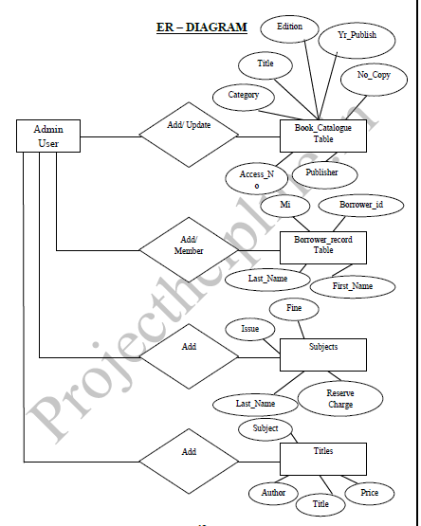

# DFD Model

# DFD.PNG

##### 

# 9. LIMITATION

This application has Perform the limited activity of College Library Management System .These limitation are following:-

* This Application does not support networking.
* It maintained the limited operation data.
* Reporting is not in well formed.

# Logic Model:-

Logic models are narrative or graphical depictions of processes in real life that communicate the underlying assumptions upon which an activity is expected to lead to a specific result. Logic models illustrate a sequence of cause-and-effect relationships-a systems approach to communicate the path toward the desired result.

**INPUT :--**

1. Library Management System for maintained the record of books to must have input data from the end user.
2. To enter the record of new books.
3. Prepare the cataloguing as input data is requirement of activity of College Library.
4. To provide various search options to know the availability of books in the Library.
5. To search the data in database.
6. To enter the cost, discount of the relative book.

# PROCESS LOGIC :-

In Library Management System has Perform the various type of processing. These are following:

1. Selecting and ordering items for the collection and maintaining the accounts.
2. Creating records for material held in the collection.
3. Search the registered books and members-Via an Online Public Access Catalogue (OPAC).
4. Calculate the actual cost of book.
5. Report the Available books.
6. To view the requirements of Library.

Scope of Library management System:-

The new Combats Library Management System that is to be developed provides the Student of the University Library and staff with books information, online viewing of books and many other facilities. The Library Management System is supposed to have the following detailed features. The early release of the new system will contain an online registration form for the student , an online E-Book portal and a backend database to process and store registration information and the Library System’s information, a secure internal network and a Library’s administrators portal. This initial relapse will sloes include installation configuration, and support documentation for the Librarian and the University Students and Staff. Since this initial release will be fully functional, it is essential to include user and technical support documentation to easily use and configure the E-portal so it is practically usable in the new Library environment. The product provide the members with online blocking of capabilities and the Library Management System is up and running all day.

**Conclusion :**

* The Library Management System allows the user to store the books details and the person’s details.
* This software allows storing the details of all the data related to library.
* The implementation of the system will reduce data entry time and provide readily calculated reports.